Graduation Regalia Ordering Instructions

- Navigate to http://www.jostens.com/apps/store/customer/1007006/Saybrook-University
- Select the “Graduation Caps & Gowns” link or click on the photo of the graduates
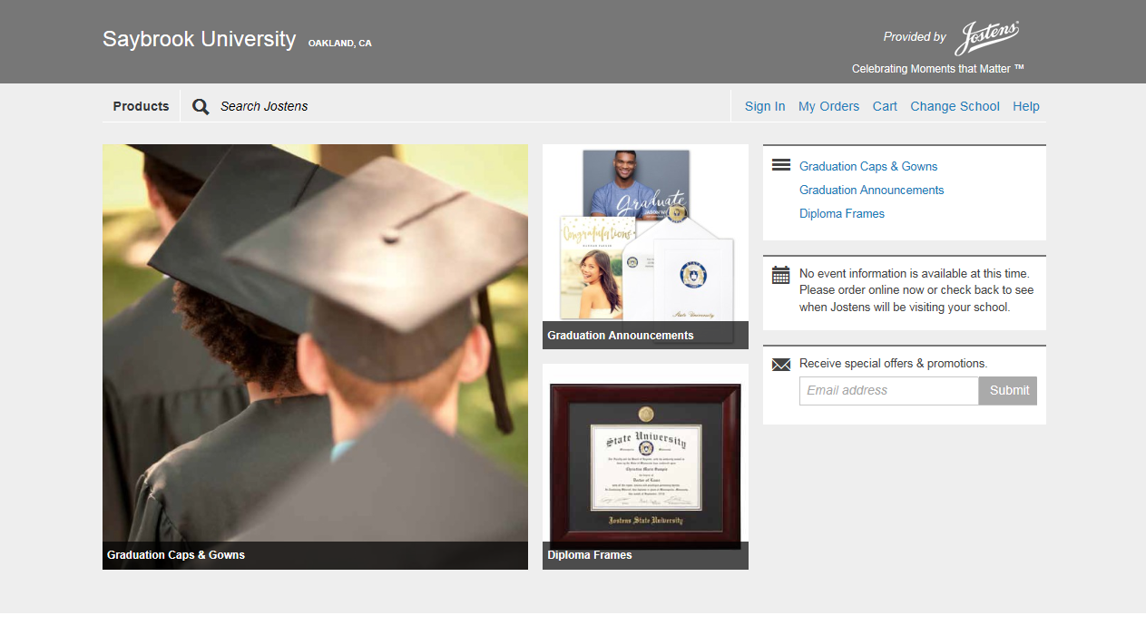

- Select the “Student” from the pop up dialog box
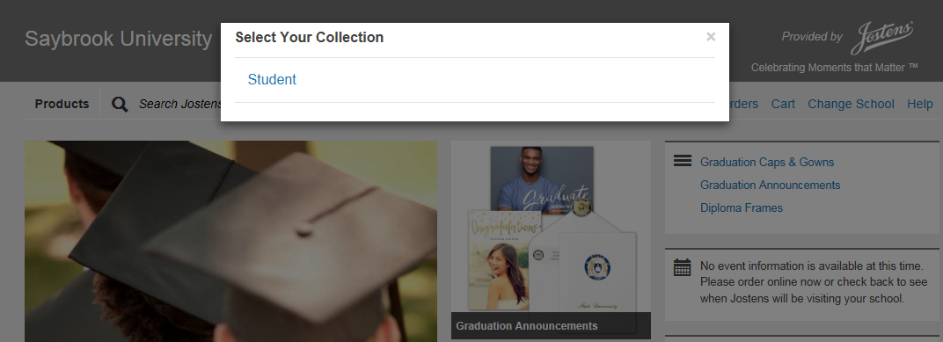

- Select between Master or Doctorate degree
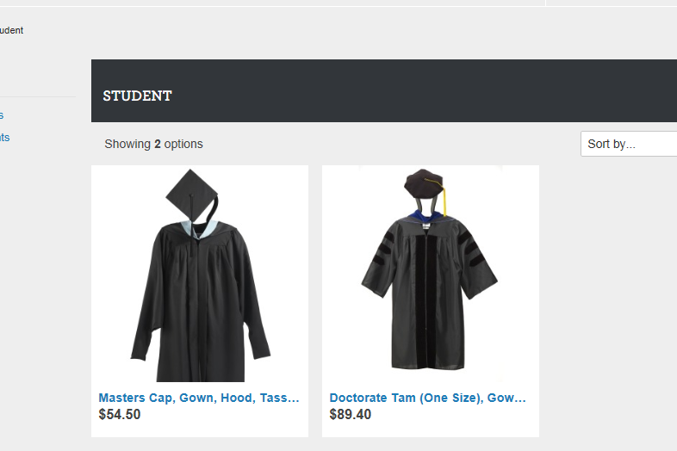

- Click the “Customize” button
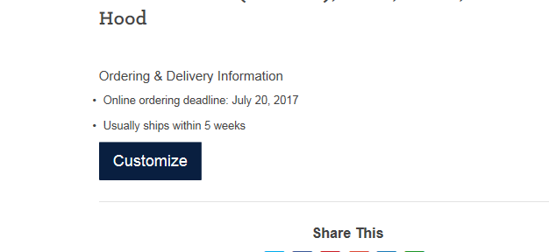

- Enter Height and Weight, then click “Next”
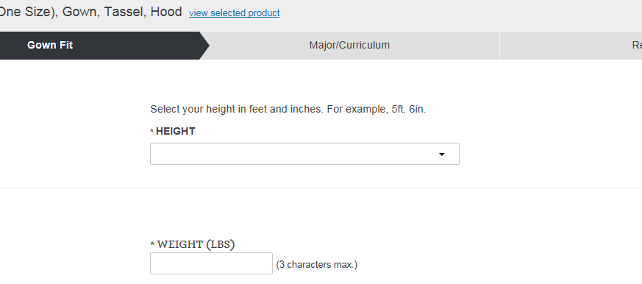

- Select your area of study. Please see chart below to ensure you order the appropriate hood colors
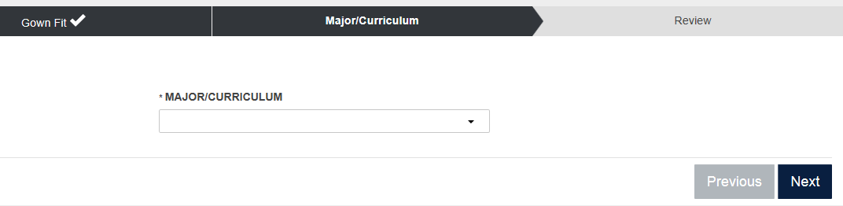
Saybrook Degree | Major/Curriculum choice
All PhD | PhD
PsyD | Psychology
MS IFN | Nutrition Science
MS MBM | Medicine
MA IWC | Health
MA TSC | Social Science
MA Management | Business Management
MA Psychology | Psychology
MA Counseling | Counseling
MA Psychology, Counseling Specialization | Counseling

- Verify information and if correct click “Add to Cart”
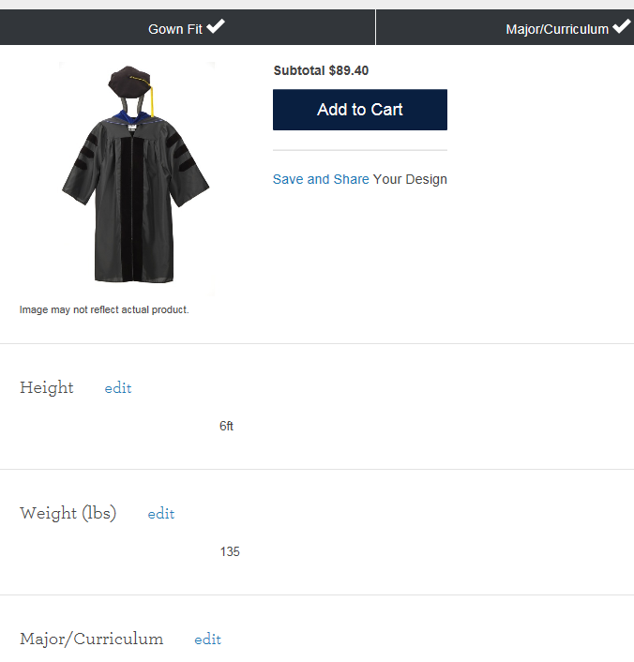

- Review order details, fill out first name and last name fields, then click “Checkout”
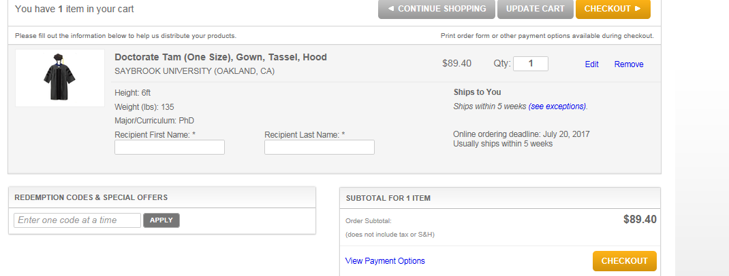

- Continue as a guest
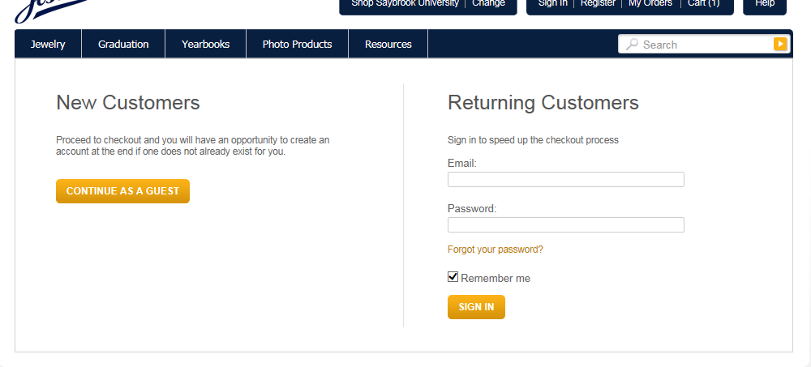

- Complete billing and shipping information then click “Continue”
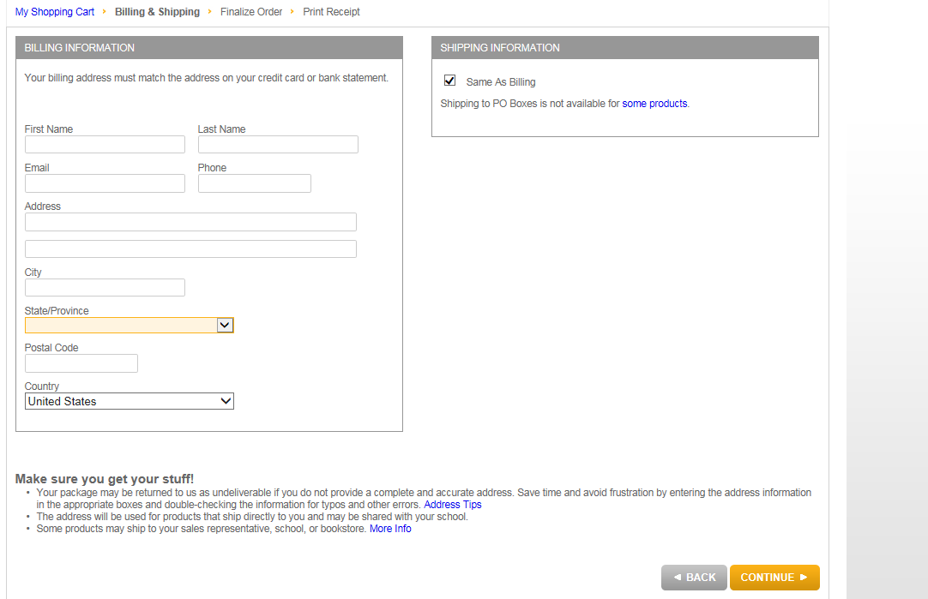
- Complete payment information and submit order

You will receive a confirmation email within 24 hours. If one does not arrive please contact Jostens Customer Care at 800-854-7464.

